1. 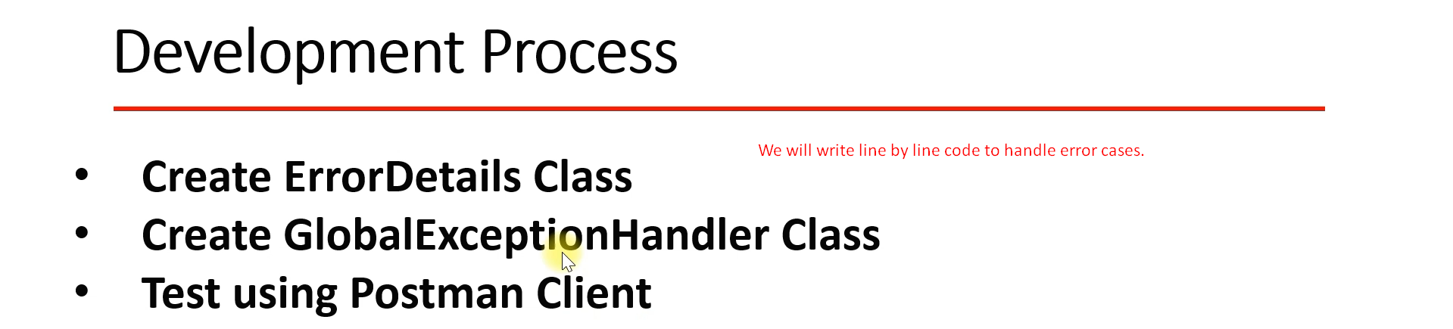
2. 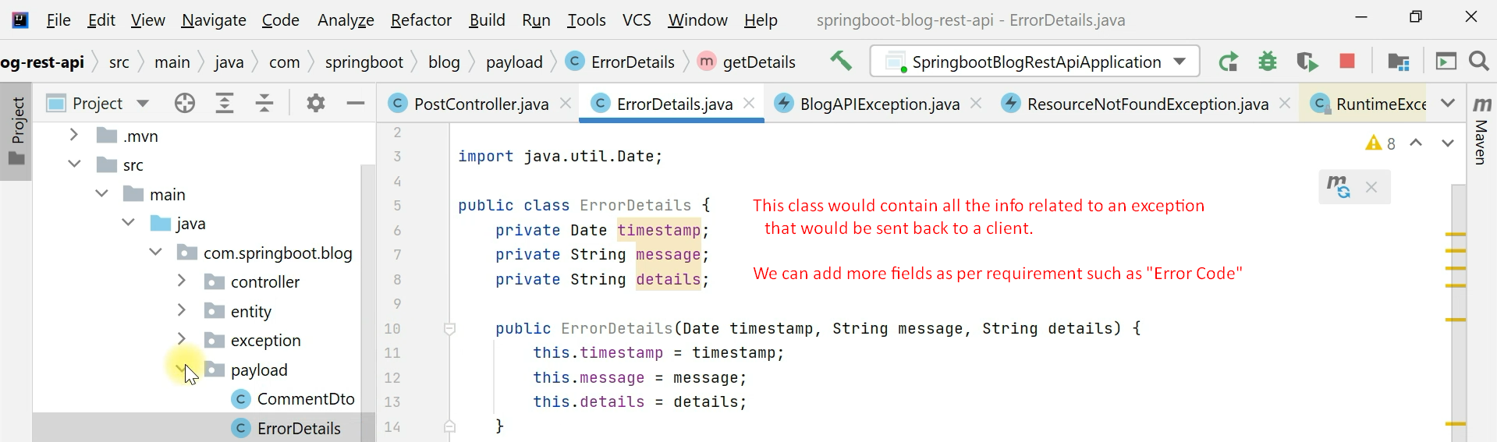
3. 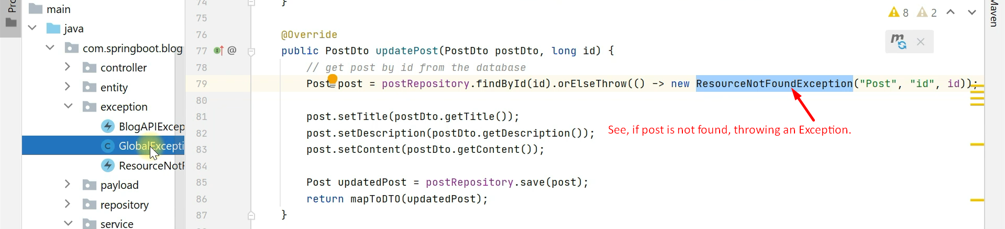
4. 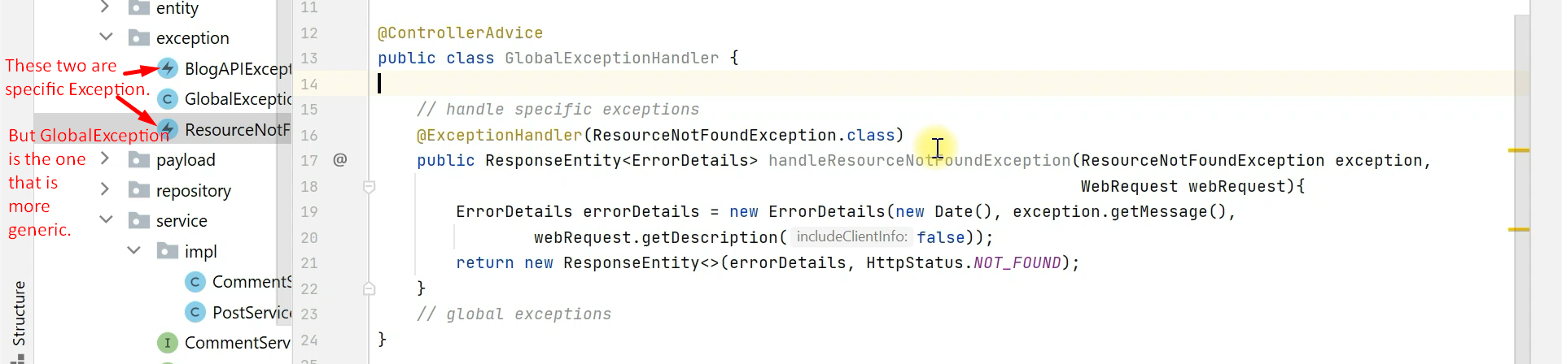
5. 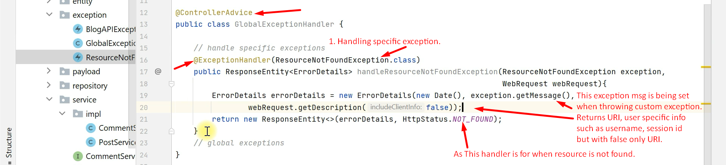
6. 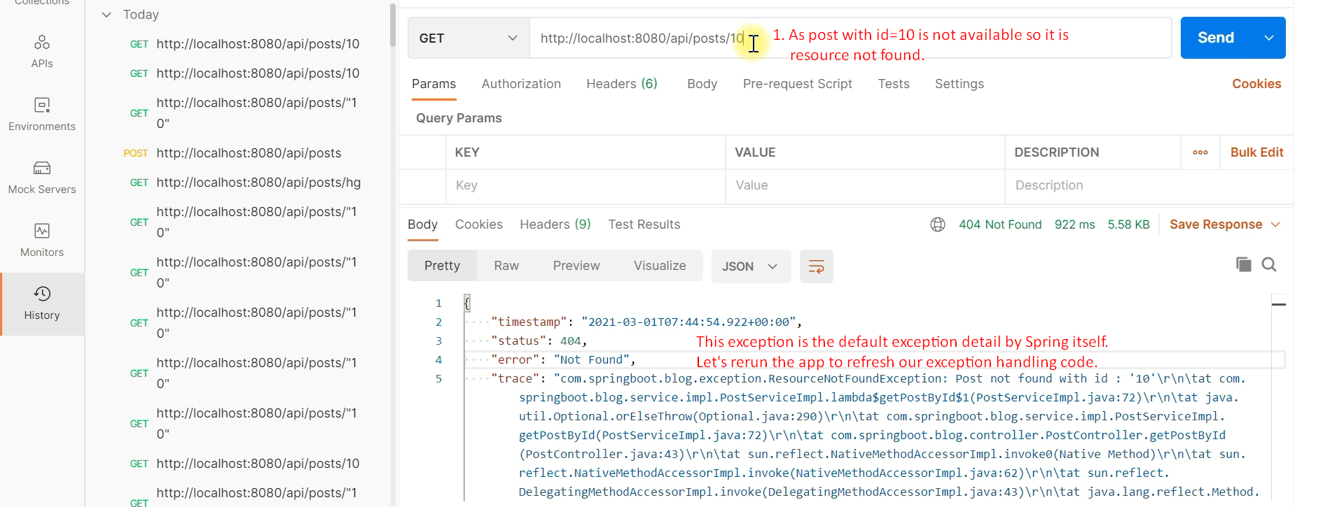
7. 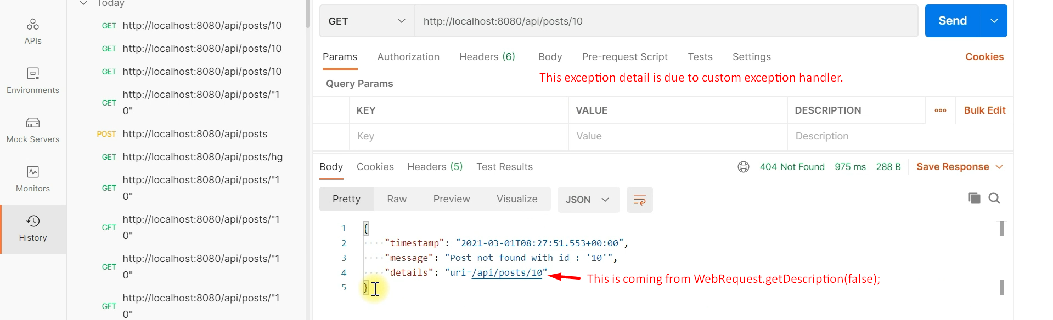
8. Let’s see how to handle Global Exception in next lecture.